Snake Game AI agent using Rule-Based Agent
Omika Maurya, Ayan Ahamad, Anurag Yamuna(2CSE13)
IILM University Greater Noida

Abstract
This paper presents the design and implementation of an AI-based Snake Game developed using Python and Pygame. The system utilizes a rule-based intelligent agent to control the movement of the snake automatically. The agent makes decisions based on the position of the food and ensures safe movement by avoiding collisions with walls and its own body. The project demonstrates the application of artificial intelligence concepts in game development. Although reinforcement learning techniques were explored during the research phase, the final implementation is based on rule-based logic due to simplicity and time constraints. The system successfully demonstrates automated gameplay with efficient decision-making.
Keywords: Artificial Intelligence, Snake Game, Rule-Based Agent, Pygame

1. Introduction
The Snake Game is one of the most popular and classic games used for understanding programming logic and artificial intelligence concepts. Traditionally, the game is controlled manually by the user. However, in this project, an AI-based approach is implemented where an intelligent agent automatically controls the snake.
The main objective of the game is to collect food items while avoiding collisions with walls and the snake’s own body. This project demonstrates how simple AI techniques can be applied to automate gameplay and improve decision-making.

2. Objectives
The main objectives of this project are:
- To develop a Snake Game using Python
- To implement an AI-based agent for automatic movement
- To design a system that avoids collisions
- To demonstrate basic artificial intelligence concepts

3. Methodology
The system is based on a rule-based intelligent agent. The agent continuously monitors the position of the snake and the food. Based on this information, it decides the next movement direction.
The following steps are involved:
- Detect the position of the snake and food
- Compare coordinates to determine direction
- Check for possible collisions
- Choose a safe path
Although reinforcement learning techniques such as Q-learning were studied during the research phase, they were not implemented in the final system. The current implementation focuses on deterministic rule-based logic.

4. System Architecture
The system follows a simple pipeline:
Game Environment → AI Agent → Decision Making → Movement → Output
The AI agent acts as the decision-making unit, which takes inputs from the game and produces movement actions.
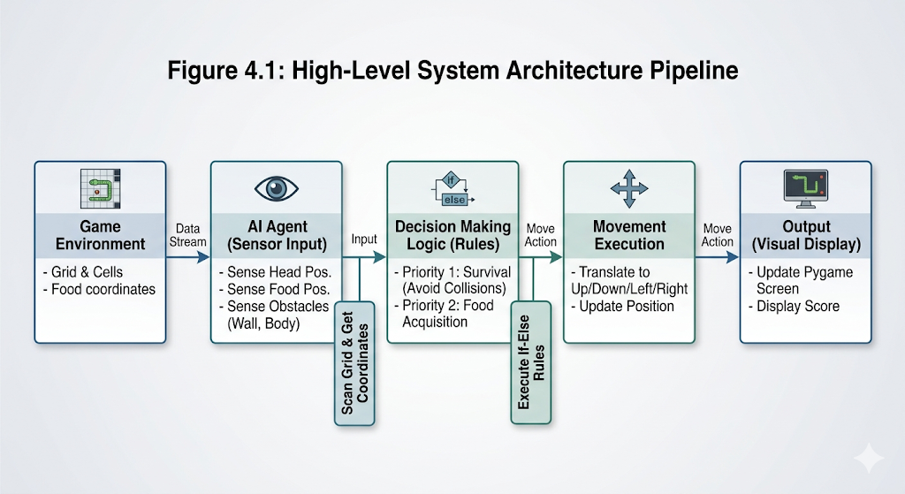

5. Implementation
The project is implemented using Python programming language along with the Pygame library. The system consists of the following components:
- Game Engine: Handles rendering and display
- Snake Logic: Manages movement and growth
- Food Generation: Random placement of food
- Collision Detection: Detects game over conditions
- AI Agent: Decides movement direction
The AI agent uses conditional statements to determine the safest and most efficient path toward the food.

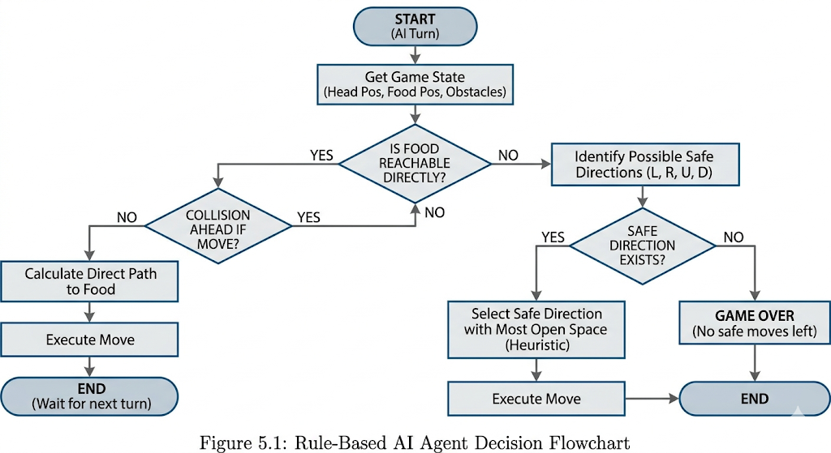

6. Results and Discussion
The system performs successfully by automating the snake’s movement. The AI agent is able to:
- Move toward the food
- Avoid collisions in most scenarios
- Maintain continuous gameplay
However, since the system is rule-based, it may fail in complex situations where advanced decision-making is required.

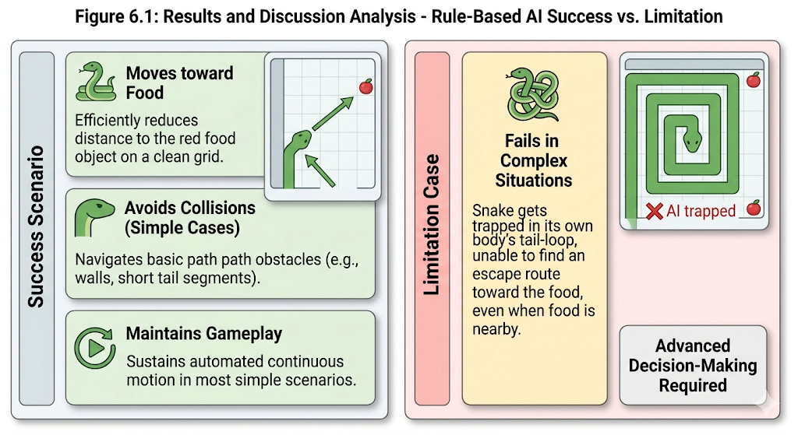

7. Limitations
The project has the following limitations:
- Uses basic rule-based logic
- No learning capability
- Performance is limited in complex scenarios

8. Future Scope
The project can be enhanced in the following ways:
- Implementation of Reinforcement Learning (Q-Learning)
- Use of advanced algorithms like A* or BFS
- Development of a web-based version
- Improved decision-making using Machine Learning

9. Conclusion
This project demonstrates the implementation of an AI-based Snake Game using a rule-based agent. It highlights how basic artificial intelligence techniques can be applied to automate gameplay. The system provides a strong foundation for further improvements using advanced AI methods.

10. References
[1] Python Documentation
[2] Pygame Documentation
[3] Introduction to Artificial Intelligence Concepts

